 | 7.1.8 Editors - 3D View - Header - Object menu
Table of content
Detailed Table of content 3
Object menu 11
Transform 11
To Sphere 11
Shear 12
Bend 13
Push/Pull 13
Move Texture Space 14
Scale Texture Space 15
Align to Transform Orientation 16
Randomize Transform 17
Align Objects 17
Set Origin 18
Geometry to Origin 18
Origin to Geometry 18
Origin to 3D cursor 18
Origin to Center of Mass(Surface) 18
Origin to Center of Mass(Volume) 18
Mirror 19
Interactive Mirror 19
X Y Z Global 19
X Y Z Local 19
Clear 20
Clear 20
Apply 21
Apply 21
Visual Transform 22
Make Instances Real 22
Snap 22
Selection to Cursor 22
Selection to Cursor(Keep Offset) 22
Selection to Active 23
Selection to Grid 23
Cursor to Selected 23
Cursor to World Origin 23
Cursor to Active 23
Cursor to Grid 23
From Duplicate ... to Paste 23
Duplicate Objects 23
Duplicate Linked 24
Join 26
Delete 26
Delete Global 26
Copy 26
Paste 27
Parent 27
Object 27
Object ( Keep Transform) 27
Armature Deform 28
With empty Groups 28
With Envelope Weights 28
With automatic Weights 28
Bone 28
Bone Relative 28
Curve Deform 28
Follow Path 29
Path Constraint 29
Lattice Deform 29
Vertex 30
Vertex (Triangle) 30
Last Operator Make Parent 31
Keep Transform 31
Object (without inverse) 31
Clear Parent 31
Clear and Keep Transformation 31
Clear Parent Inverse 31
Relations 32
Make Proxy 32
Make Library Override 32
Convert Proxy to Override 33
Make Instance Face 33
Make Local 33
Make Single User 34
Constraints 34
Track 35
Damped Track Constraint 35
Track to Constraint 36
Lock Track Constraint 36
Link / Transfer Data 36
Link Object to Scene 37
Object Data, Materials .. etc 37
Copy UV Maps 37
Transfer Mesh Data 37
Transfer Mesh Data Layout 39
Shade Smooth and Shade Flat 40
Animation 40
Insert Key frame 40
Delete Key frame 41
Clear Key frames 41
Bake Action 41
Bake Mesh to Grease Pencil 42
Bake Mesh Animation to Grease Pencil 42
Rigid Body 43
Add Active 44
Add Passive 44
Remove 44
Change shape 44
Calculate Mass 44
Quick Effects 45
Quick Fur 45
Quick Explode 45
Quick Smoke 45
Quick Fluid 45
Subdivide 46
Last Operator Subdivision Set 46
Convert to 46
Curve 46
Mesh 47
Grease Pencil 47
Point Cloud 47
Gpencil to Path 47
Gpencil to Bezier Curves 48
Gpencil to Mesh 48
Trace Image to Grease Pencil 48
Show/Hide 48
Show Hidden 48
Hide Selected 48
Hide Unselected 49
Clean Up 49
Clear Vertex Group Weights 49
Limit Total Vertex Groups 49
Remove Unused Material Slots 49
Object specific menu items 49
Curve and Text 49
Empty, Image and Force Fields 50
Camera 50
Adjust Focal Length 50
Adjust Focus Distance 50
Light 50
Point light 51
Sun light 52
Spot light 52
Area light 54

Detailed Table of content

Detailed table of content
Detailed Table of content 3
Object menu 11
Transform 11
To Sphere 11
Usage 11
Last Operator To Sphere 11
Factor 11
Proportional editing 11
Proportional Falloff 12
Proportional Size 12
Connected 12
Projected(2D) 12
Shear 12
Last Operator Shear 12
Offset 12
Shear Axis 12
Axis 12
Axis Ortho 12
Orientation 12
Proportional editing 13
Proportional Falloff 13
Proportional Size 13
Connected 13
Projected(2D) 13
Bend 13
Push/Pull 13
Last Operator Push/Pull 13
Factor 13
Proportional editing 13
Proportional Falloff 13
Proportional Size 14
Connected 14
Projected(2D) 14
Move Texture Space 14
Last Operator Move 14
Move 14
Orientation 14
Proportional editing 14
Proportional Falloff 15
Proportional Size 15
Connected 15
Projected(2D) 15
Scale Texture Space 15
Last Operator Resize 15
Move 15
Orientation 15
Proportional editing 15
Proportional Falloff 15
Proportional Size 15
Connected 15
Projected(2D) 15
Align to Transform Orientation 16
Last Operator Transform 16
Values 16
Axis 16
Orientation 16
Proportional editing 16
Proportional Falloff 16
Proportional Size 16
Connected 16
Projected(2D) 16
Randomize Transform 17
Last Operator Randomize Transform 17
Random Seed 17
Transform Delta 17
Randomize Location checkbox 17
Location edit boxes 17
Randomize Rotation checkbox 17
Rotation edit boxes 17
Randomize Scale checkbox 17
Scale Even 17
Scale edit boxes 17
Align Objects 17
Last Operator Align Objects 18
High Quality 18
Align Mode 18
Relative To 18
Align 18
Set Origin 18
Geometry to Origin 18
Origin to Geometry 18
Origin to 3D cursor 18
Origin to Center of Mass(Surface) 18
Origin to Center of Mass(Volume) 18
Last Operator Set Origin 18
Type 18
Center 19
Mirror 19
Interactive Mirror 19
Usage: 19
X Y Z Global 19
X Y Z Local 19
Last Operator Mirror 19
Orientation 19
Proportional editing 19
Proportional Falloff 19
Proportional Size 19
Connected 19
Projected(2D) 19
Clear 20
Clear 20
Location 20
Last Operator Clear Location 20
Clear Delta 20
Rotation 20
Last Operator Clear Rotation 20
Clear Delta 20
Scale 20
Last Operator Clear Scale 20
Clear Delta 20
Origin 20
Apply 21
Apply 21
Location, Rotation, Scale, All Transforms and Rotation&Scale 21
Last Operator Apply Object Transform. 21
Location 21
Rotation 21
Scale 21
Apply Properties 21
Location, Rotation, Scale and All Transforms to Deltas 21
Last Operator Transforms to Deltas 22
Mode 22
Reset Values 22
Animated Transform to Deltas 22
Visual Transform 22
Make Instances Real 22
Last Operator Make Instances Real 22
Parent 22
Keep Hierarchy 22
Snap 22
Selection to Cursor 22
Selection to Cursor(Keep Offset) 22
Last operator Snap Selection to Cursor 23
Offset 23
Selection to Active 23
Selection to Grid 23
Cursor to Selected 23
Cursor to World Origin 23
Cursor to Active 23
Cursor to Grid 23
From Duplicate ... to Paste 23
Duplicate Objects 23
Last Operator Duplicate 24
Duplicate Objects 24
Linked 24
Move X , Y , Z 24
Orientation 24
Proportional editing 24
Proportional Falloff 24
Proportional Size 24
Connected 24
Projected(2D) 24
Duplicate Linked 24
Last Operator Duplicate Linked 25
Duplicate Objects 25
Linked 25
Move X, Y, Z 25
Orientation 26
Proportional editing 26
Proportional Falloff 26
Proportional Size 26
Connected 26
Projected(2D) 26
Join 26
Delete 26
Delete Global 26
Copy 26
Paste 27
Last Operator Paste Selection from Buffer 27
Select 27
Active Collection 27
Parent 27
Object 27
Object ( Keep Transform) 27
Armature Deform 28
With empty Groups 28
With Envelope Weights 28
With automatic Weights 28
Bone 28
Bone Relative 28
Curve Deform 28
Follow Path 29
Path Constraint 29
Lattice Deform 29
Vertex 30
Vertex (Triangle) 30
Last Operator Make Parent 31
Type 31
Keep Transform 31
Object (without inverse) 31
Clear Parent 31
Clear and Keep Transformation 31
Clear Parent Inverse 31
Last Operator Clear Parent 31
Relations 32
Make Proxy 32
How to: 32
Make Library Override 32
Convert Proxy to Override 33
Make Instance Face 33
Usage: 33
Make Local 33
Make Single User 34
Constraints 34
Add Constraints ( With Targets) 34
Last Operator Add Constraints (with Target) 35
Type 35
Copy Constraints to Selected Objects 35
Clear Object Constraints 35
Track 35
Damped Track Constraint 35
Track to Constraint 36
Lock Track Constraint 36
Clear Track 36
Last Operator Clear track 36
Type 36
Clear Track - Keep Transformation 36
Last Operator Clear track 36
Type 36
Link / Transfer Data 36
Link Object to Scene 37
Object Data, Materials .. etc 37
Last Operator Link Data 37
Type 37
Copy UV Maps 37
Transfer Mesh Data 37
Last Operator Transfer Mesh Data 38
Freeze Operator 38
Data Type 38
Create Data 38
Edge Mapping 38
Topology 38
Nearest Vertice 38
Nearest Edge 38
Nearest Face Edge 38
Projected Edge Interpolation 38
Auto Transform 38
Only Neighbor Geometry 38
Max Distance 39
Ray Radius 39
Mix Mode 39
Below Threshold 39
Above Threshold 39
Replace 39
Mix Factor 39
Transfer Mesh Data Layout 39
Last Operator Transfer Mesh Data Layout 39
Data Type 39
Exact Match 40
Source Layers Selection 40
Mygroup 40
Active Layer 40
All Layers 40
Destination Layers Matching 40
By Name 40
By Order 40
Active Layer 40
Shade Smooth and Shade Flat 40
Animation 40
Insert Key frame 40
Insert Key frame Menu 41
Delete Key frame 41
Clear Key frames 41
Bake Action 41
Last Operator Bake Action 41
Start Frame 41
End Frame 41
Frame Step 42
Only Selected Bones 42
Visual Keying 42
Clear Constraints 42
Clear Parents 42
Overwrite current Action 42
Bake Data 42
Bake Mesh to Grease Pencil 42
Bake Mesh Animation to Grease Pencil 42
Target Object 42
Start Frame 42
End Frame 42
Step 42
Thickness 43
Threshold Angle 43
Stroke Offset 43
Only Seam Edges 43
Export Faces 43
Only Selected Keyframes 43
Target Frame 43
Projection Type 43
OK 43
Last Operator Bake Mesh Animation to Grease Pencil 43
Rigid Body 43
Add Active 44
Add Passive 44
Last Operator Add Rigid bodies 44
Remove 44
Change shape 44
Last Operator Change Collision shape 44
Calculate Mass 44
Last Operator Calculate Mass 45
Material Preset 45
Density 45
Quick Effects 45
Quick Fur 45
Quick Explode 45
Quick Smoke 45
Quick Fluid 45
Subdivide 46
Last Operator Subdivision Set 46
Level 46
Relative 46
Convert to 46
Curve 46
Mesh 47
Grease Pencil 47
Point Cloud 47
Last Operator Convert to 47
Target 47
Target Point Cloud, Mesh, Curve 47
Keep Original 47
Target Grease Pencil 47
Keep Original 47
Thickness 47
Threshold Angle 47
Stroke Offset 47
Only Seam Edges 47
Export Faces 47
Gpencil to Path 47
Gpencil to Bezier Curves 48
Gpencil to Mesh 48
Last Operator Convert Grease Pencil 48
Type 48
Bevel Depth 48
Bevel Resolution 48
Normalize Weight 48
Radius Factor 48
Link Stroke 48
Trace Image to Grease Pencil 48
Show/Hide 48
Show Hidden 48
Hide Selected 48
Hide Unselected 49
Clean Up 49
Clear Vertex Group Weights 49
Limit Total Vertex Groups 49
Remove Unused Material Slots 49
Object specific menu items 49
Curve and Text 49
Adjust Extrusion 49
Adjust Offset 49
Empty, Image and Force Fields 50
Adjust Empty Display Size 50
Camera 50
Adjust Focal Length 50
Adjust Focus Distance 50
Light 50
Power 51
Interactive Light Track 51
Point light 51
Adjust Light Power 51
Adjust Light Radius 51
Sun light 52
Adjust Light Power 52
Adjust Sun Light Angle 52
Interactive Light Track 52
Spot light 52
Adjust Light Power 52
Adjust Light Radius 53
Adjust Spot Light Size 53
Adjust Spot Light Blend 53
Interactive Light Track 53
Area light 54
Adjust Light Power 54
Adjust Area Light Size 54
Interactive Light Track 54

Object menu

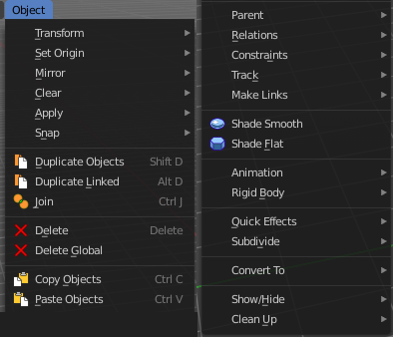
The object menu in Object mode provides you with tools to work at Object level.

It contains things like undo redo, copy and paste, delete and other general tools. But also some object specific tools, like the Convert to menu. Or Transform items, and many more.

There are lots of tools in this menu. So we will divide it into sub chapters.

Transform

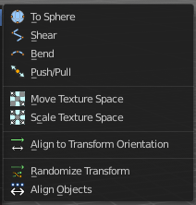
The transform sub menu contains functionality for some kind of transformations.

To Sphere
Shapes a selection of objects into the shape of a sphere. The calculation happens with the object origins.
In Object mode this tools requires to have more than one object selected.

Usage
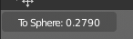
Select the objects, activate the tool, then drag the mouse in the 3D viewport. In the header you will read the current factor then. Which tells you how close you are towards the sphere shape.
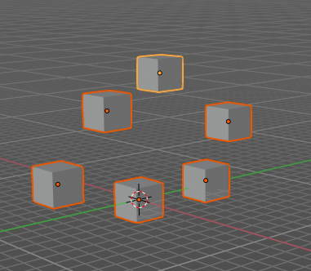
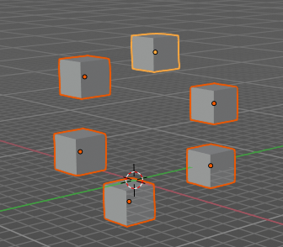

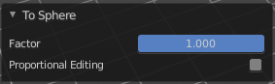
Last Operator To Sphere

Factor
The factor to transform the selection into a shape form.

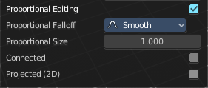
Proportional editing
Enables proportional editing. Activating proportional editing reveals further settings.

Proportional Falloff
Adjust the falloff methods.

Proportional Size
See and adjust the falloff radius.

Connected
The proportional falloff gets calculated for connected parts only.

Projected(2D)
The proportional falloff gets calculated in the screen space. Depth doesn't play a role. When it's in the radius, then it gets calculated.

Shear
Shear shears the selection.
In Object mode this tools requires to have more than one object selected.

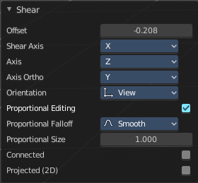
Last Operator Shear

Offset
Adjust an offset.

Shear Axis
The shear tool works along a imaginary 2d plane. The shear axis controls if the items are sheared along the x or the y axes of this plane. This is the plane along which the transformation happens. You can shear along the x or the y axis of this plane.
To make things even more complicated, the orientation of this imaginary plane is defined by the Axis and Axis Ortho items below.

Axis
Defines one axis of the imaginary shear axis plane.

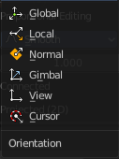
Axis Ortho
Defines the other axis of the imaginary shear axis plane.

Orientation
Choose the orientation for the shear action.

Proportional editing
Enables proportional editing. Activating proportional editing reveals further settings.

Proportional Falloff
Adjust the falloff methods.

Proportional Size
See and adjust the falloff radius.

Connected
The proportional falloff gets calculated for connected parts only.

Projected(2D)
The proportional falloff gets calculated in the screen space. Depth doesn't play a role. When it's in the radius, then it gets calculated.

Bend
Bends the selection.
In Object mode this tools requires to have more than one object selected.

Push/Pull
It pushes or pulls the object positions relative to the center of the selection.
In Object mode this tool requires to have more than one object selected.

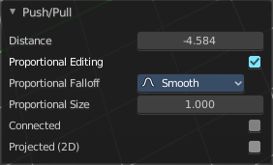
Last Operator Push/Pull

Factor
Adjust the strength of influence of the tool.

Proportional editing
Enables proportional editing. Activating proportional editing reveals further settings.

Proportional Falloff
Adjust the falloff methods.

Proportional Size
See and adjust the falloff radius.

Connected
The proportional falloff gets calculated for connected parts only.

Projected(2D)
The proportional falloff gets calculated in the screen space. Depth doesn't play a role. When it's in the radius, then it gets calculated.

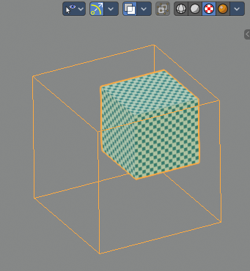
Move Texture Space
This tool relies at the move tool. With the difference that it moves the texture space instead of the object. It has also a very special use case, and just works with a material with a Texture Coordinate / Generated node. And requires to have the shading at Material or Rendered to see a result in the viewport.
The yellow cage represents the texture space. The actual UV mapping does not change.
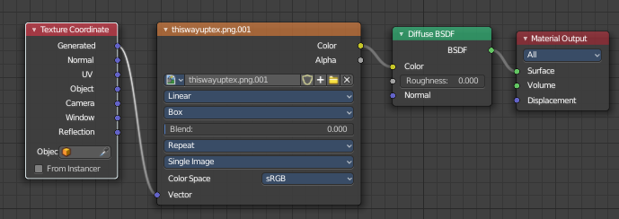

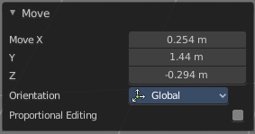
Last Operator Move

Move
Adjust in which directions you want to transform.

Orientation
Choose the orientation.

Proportional editing
Enables proportional editing. Activating proportional editing reveals further settings.

Proportional Falloff
Adjust the falloff methods.

Proportional Size
See and adjust the falloff radius.

Connected
The proportional falloff gets calculated for connected parts only.

Projected(2D)
The proportional falloff gets calculated in the screen space. Depth doesn't play a role. When it's in the radius, then it gets calculated.

Scale Texture Space
Scale Texture space is similar to the Move texture Space. With the only difference that it scales the UV space instead of moving it.

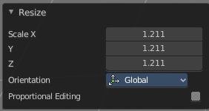
Last Operator Resize

Move
Adjust in which directions you want to transform.

Orientation
Choose the orientation.

Proportional editing
Enables proportional editing. Activating proportional editing reveals further settings.

Proportional Falloff
Adjust the falloff methods.

Proportional Size
See and adjust the falloff radius.

Connected
The proportional falloff gets calculated for connected parts only.

Projected(2D)
The proportional falloff gets calculated in the screen space. Depth doesn't play a role. When it's in the radius, then it gets calculated.

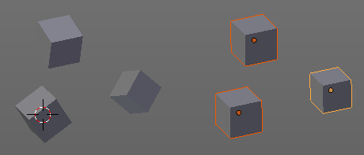
Align to Transform Orientation
Align to Transform Orientation rotates the selected objects so that their local orientation matches the active transform orientation in the Transform orientation panel or the Orientation selection in the Transform Operator panels.
For example when you have a few cubes that are rotated differently, then perform align to transform orientation with Global coordinates, then the cubes rotations gets set back to 0/0/0

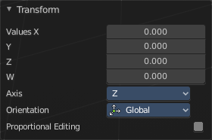
Last Operator Transform

Values
These values can't be edited. The tool aligns to zero, so the values turns to zero.

Axis
These values doesn't matter. Changing them does nothing.

Orientation
Choose the orientation in which the transform should happen.

Proportional editing
Enables proportional editing. Activating proportional editing reveals further settings.

Proportional Falloff
Adjust the falloff methods.

Proportional Size
See and adjust the falloff radius.

Connected
The proportional falloff gets calculated for connected parts only.

Projected(2D)
The proportional falloff gets calculated in the screen space. Depth doesn't play a role. When it's in the radius, then it gets calculated.

Randomize Transform
This tool allows to randomize position rotation and scale of selected objects. Each object gets threaten individually by a random value.
It starts with zeroed values. You need to adjust the values in the last operator.

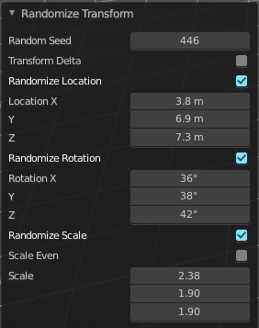
Last Operator Randomize Transform

Random Seed
Adjust the random seed value.

Transform Delta
Randomize Delta transform values instead of the regular transform values.

Randomize Location checkbox
With this checkbox ticked the location of the selected objects gets randomize

Location edit boxes
Adjust the strength of the transform for the single axis.

Randomize Rotation checkbox
With this checkbox ticked the rotation of the selected objects gets randomize

Rotation edit boxes
Adjust the strength of the transform for the single axis.

Randomize Scale checkbox
With this checkbox ticked the scale of the selected objects gets randomized.

Scale Even
Use the same scale values for all axis.

Scale edit boxes
Adjust the strength of the transform for the single axis.

Align Objects
Align Objects allows you to align the selected objects in various ways. You need to adjust the settings in the Last operator panel. The align operation happens in world coordinates.

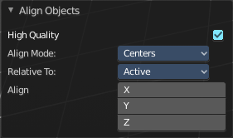
Last Operator Align Objects

High Quality
When ticked the calculation gets performed in a higher precision.

Align Mode
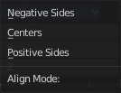
Align Mode is a drop-down box choose between different align modes.

Relative To
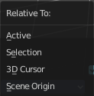
Relative to is a drop-down box. Here you adjust in what method the alignment happens.
Relative to the active object, to the center of selection, to the 3D cursor or to the scene origin.

Align
Turn on or off the single axis for the align operation.

Set Origin

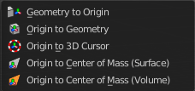
Set origin sets the origin of the selected objects to a chosen location.

Geometry to Origin
Sets the geometry to origin.

Origin to Geometry
Sets the origin to geometry.

Origin to 3D cursor
Sets the origin to the 3D cursor.

Origin to Center of Mass(Surface)
Sets the origin to the center of mass, calculating it from the center of the surface area.

Origin to Center of Mass(Volume)
Sets the origin to the center of mass, calculating from the center of the Volume. It must be manifold geometry with consistent normals.

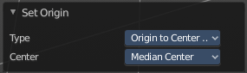
Last Operator Set Origin
The last operator is the same for all set origin methods.

Type
Choose the method again.

Center
Use the median center or the bounds center for calculation.

Mirror
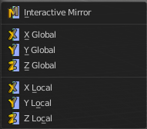
Mirrors the selection.

Interactive Mirror
Mirrors the selection.

Usage:
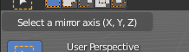
Activate the tool. In the header you will now see further instructions. Which is: type in the axis at which you want to mirror. Interactive mirroring starts in Global space. You can change the orientation in the last operator.

X Y Z Global
Mirrors along the global axis.

X Y Z Local
Mirrors along the object axis.

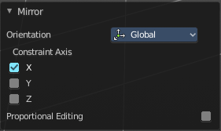
Last Operator Mirror

Orientation
Choose the orientation in which the transform should happen.

Proportional editing
Enables proportional editing. Activating proportional editing reveals further settings.

Proportional Falloff
Adjust the falloff methods.

Proportional Size
See and adjust the falloff radius.

Connected
The proportional falloff gets calculated for connected parts only.

Projected(2D)
The proportional falloff gets calculated in the screen space. Depth doesn't play a role. When it's in the radius, then it gets calculated.

Clear

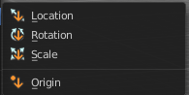
Clear
Clear Transform is a menu where you can clear the transform for location, rotation, scale and Origin. Clear means in this conjunction that the values gets reset.
When you have for example a cube at X 5, and clear the location, then the cube gets positioned at position X 0.

Location
Resets the location of the selected object(s).

Last Operator Clear Location

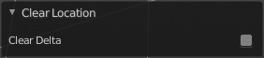
Clear Delta
With Clear Delta ticked it clears the delta transform instead of the transform.

Rotation
Resets the rotation of the selected object(s).

Last Operator Clear Rotation

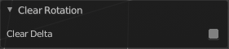
Clear Delta
With Clear Delta ticked it clears the delta transform instead of the transform.

Scale
Resets the scaling of the selected object(s).

Last Operator Clear Scale

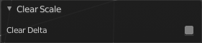
Clear Delta
With Clear Delta ticked it clears the delta transform instead of the transform.

Origin
Clear Origin requires to have a parent child relationship selected. It sets the child object to the position of the parent object.

Apply

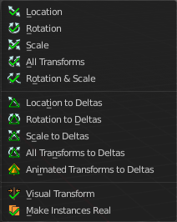
Apply
Apply is a menu where you can apply transforms in various combinations. For example, when you create a cube, then move it to let's say 3, then apply the location, then the origin gets set to 0. The position is "applied". Of special Interest is apply scale, since it resets the scale factor to 1.
Apply just works with single user objects. And it does not apply to pose position, animation curves or constraints. These tools should be used before rigging and animation.

Location, Rotation, Scale, All Transforms and Rotation&Scale
This applies the location, rotation and scale of the object.

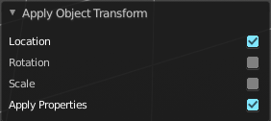
Last Operator Apply Object Transform.

Location
Applies the position, and resets origin to 0

Rotation
Applies the rotation.

Scale
Applies the Scale.

Apply Properties
Properties such as Curve Vertex Radius. Font Size and bone envelope gets applied.

Location, Rotation, Scale and All Transforms to Deltas
Transforms are absolute to the world coordinates. Delta Transforms are relative to the current transformation.
The delta transform values can be found in the Object properties, in the Delta Transform Panel.
Example use case:
Key frame a object rotation from 0 to 90 degrees. Rotate the object by 45 degrees. When you play the animation it will still rotate from 0 to 90 degrees.
Now key frame a delta rotation from 0 to 90 degrees and rotate the object by 45 degrees. When you playback the animation it will rotate from 45 to 135 degrees now. (a 90 degree difference from the current state)

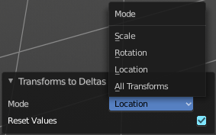
Last Operator Transforms to Deltas

Mode
Mode is a drop-down box choose the transform mode again.

Reset Values
Clears the transform values after transferring to Deltas.

Animated Transform to Deltas
Converts the “normal” transformation animations to Delta transforms. This tool requires to have key frames at the object.

Visual Transform
Applies (set) the result of a constraint, and applies this back to the Object’s location, rotation and scale.

Make Instances Real
Make Instances real makes any duplicates attached to this Object real so that they can be edited.

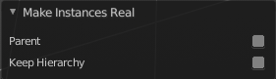
Last Operator Make Instances Real

Parent
Parent newly created objects to the original duplicator.

Keep Hierarchy
Keep Parent Child relationship.

Snap

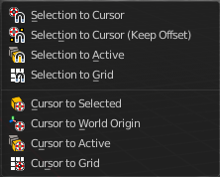
Selection to Cursor
Snaps the currently selected object(s) to the cursor location.

Selection to Cursor(Keep Offset)
Snaps the currently selected object(s) to the cursor location, but keeps the offset of the selected objects to each other. Means the center of the current selection goes to cursor position. Not every individual object.

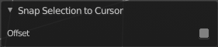
Last operator Snap Selection to Cursor

Offset
Keep the offset of the selected objects to each other.

Selection to Active
Snaps the currently selected object(s) to the active object.

Selection to Grid
Snaps the currently selected object(s) to the nearest grid point.

Cursor to Selected
Moves the cursor to the center of the selected object(s).

Cursor to World Origin
Moves the cursor to the world origin.

Cursor to Active
Moves the cursor to the center of the active object.

Cursor to Grid
Moves the cursor to the nearest grid point.

From Duplicate ... to Paste
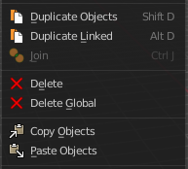

Duplicate Objects
Duplicates selected objects. The copy is completely independent. All containing data gets duplicated too. And you can edit the object instances completely independent. then.
You are automatically in grab mode, and so you can easily move the object out of position. Which is sometimes wanted, since you can position the duplicate then. But sometimes this is unwanted. A right click after releasing the mouse lets the object snap back into its creation position.
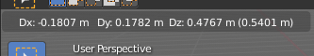
When you drag the duplicate around you will see the position values in the header.

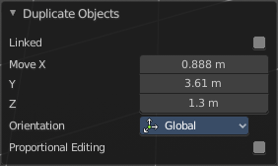
Last Operator Duplicate

Duplicate Objects

Linked
With this option ticked the duplication happens with linked data.

Move X , Y , Z
The Position of the duplicated object.

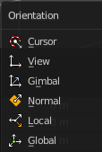
Orientation
Orientation is a drop-down box choose the type of orientation for the duplicate action.

Proportional editing
Enables proportional editing. Activating proportional editing reveals further settings.

Proportional Falloff
Adjust the falloff methods.

Proportional Size
See and adjust the falloff radius.

Connected
The proportional falloff gets calculated for connected parts only.

Projected(2D)
The proportional falloff gets calculated in the screen space. Depth doesn't play a role. When it's in the radius, then it gets calculated.

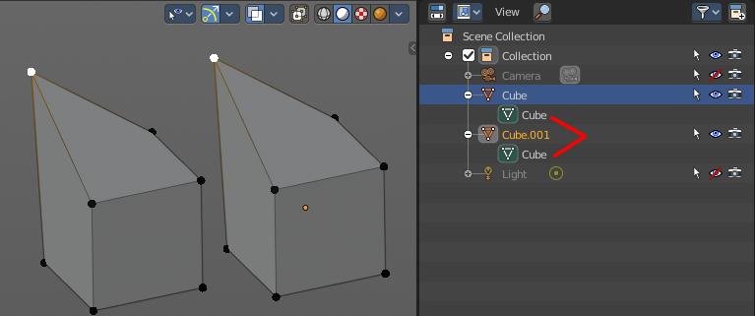
Duplicate Linked
Duplicates selected objects. The instance has its own transforms. But the duplicate shares some data with the first instance. This means when you for example edit the mesh of one of the instances, then the other instance gets modified too. As you can see this in the screenshot. Here you can also see that the mesh name is the same. The object name is different though.
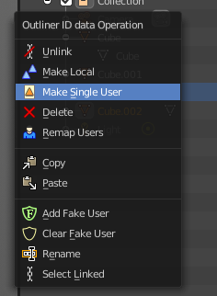
If you want to make changes to an object in the new linked duplicate independently of the original object, then you will have to manually make the object a “single-user” . This can be done for example in the Outliner, in the right click menu of the object. (Currently broken). Or in the Object menu. Choose what attached data you want to make single user.
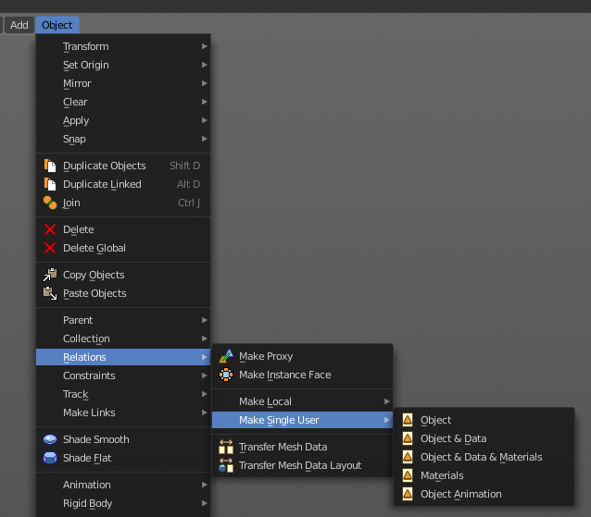

When you duplicate an object, then you are automatically in grab mode. And so you can easily move the object out of position. which is sometimes wanted, since you can position the duplicate then. But sometimes this is unwanted. A right click after releasing the mouse lets the object snap back into its creation position.
Duplicate linked instances the object data.
Explanation: Each Bforartists object type (mesh, lamp, curve, camera etc.) is composed from two parts: an Object and Object Data (sometimes abbreviated to ObData):
Object - Holds information about the position, rotation and size of a particular element.
Object Data - Holds everything else. For example. Meshes stores geometry, material lists, vertex groups, etc. . Cameras stores focal length, depth of field, sensor size, etc. .
Each object has a link to its associated object-data, and a single object-data, like a material, may be shared by many objects.

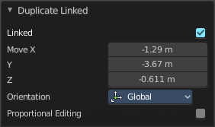
Last Operator Duplicate Linked

Duplicate Objects

Linked
With this option ticked the duplication happens with linked data.

Move X, Y, Z
The Position of the duplicated object.

Orientation
Orientation is a drop-down box choose the type of orientation for the duplicate action.

Proportional editing
Enables proportional editing. Activating proportional editing reveals further settings.

Proportional Falloff
Adjust the falloff methods.

Proportional Size
See and adjust the falloff radius.

Connected
The proportional falloff gets calculated for connected parts only.

Projected(2D)
The proportional falloff gets calculated in the screen space. Depth doesn't play a role. When it's in the radius, then it gets calculated.

Join
Joins two independent objects together and makes them one object.

This works with mesh objects and with curve objects. What does not work is to try to join mesh objects with curve objects. They are of different type.

Delete
Delete deletes the selected object(s).

Delete Global
It can be that you have more than one scene open. Delete deletes the selected object(s) in all scenes.

Copy
Copies the selected object(s).

Paste
Pastes copied object(s).

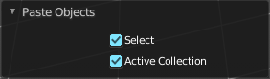
Last Operator Paste Selection from Buffer

Select
Select pasted object(s).

Active Collection
Put the pasted objects into the active collection.

Parent

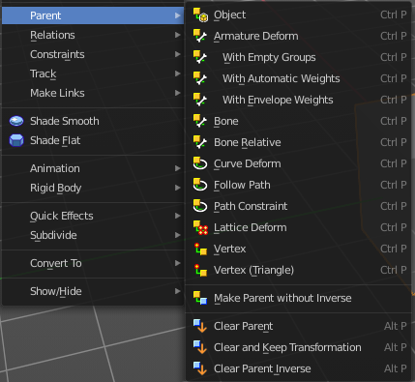
The parent menu provides you with all parenting methods at object level.
To use parenting you first have to select the source object, hold down shift, then select the target object so that both are selected. This also works in the outliner (here you can also simply hold down shift and drag the source object at the target object to make it a child). The source object becomes the child object then.

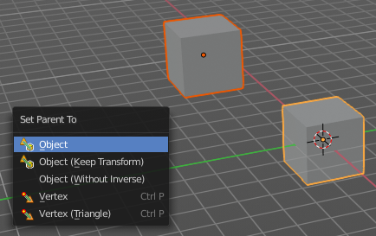
The methods are object type dependent. The armature methods requires to have a mesh and an armature. The path methods a curve. The available methods for the current selection can also be found out by pressing the hotkey ctrl P. This calls the parenting menu with just the available methods.

Object
Sets the parent to selected object.

Object ( Keep Transform)
Sets the parent to selected object, but applies all transform before the operation.

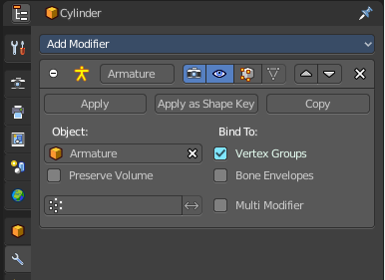
Armature parenting creates an armature modifier at the mesh.

Armature Deform
Sets the parent to selected Armature.

With empty Groups
Sets the parent to selected Armature, using empty groups.

With Envelope Weights
Sets the parent to selected Armature, using envelope weights

With automatic Weights
Sets the parent to selected Armature, with automatic weights.

Bone
Sets the parent absolute to selected Bone.

Bone Relative
Sets the parent relative to selected Bone.

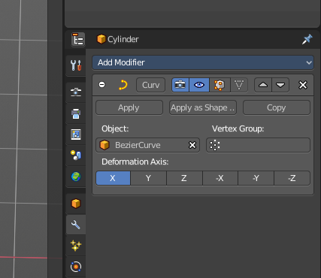
Curve Deform
Curve Deform allows you to deform a mesh by a curve shape. It adds a curve modifier at the mesh.

Usage:

Create a curve. Bend it in edit mode to your needs. Create a mesh. I have for demonstration purposes created a cylinder with several subdivisions.

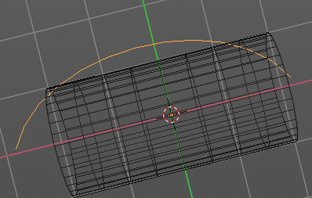

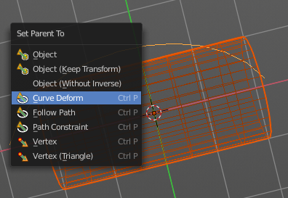
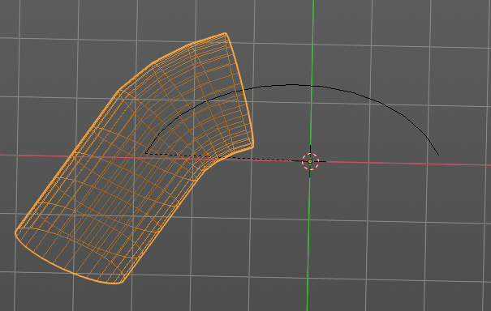

To demonstrate the only pitfall, by parenting the center of the object goes to the start point of the curve. So you better put the origin at the bottom of the cylinder before parenting.

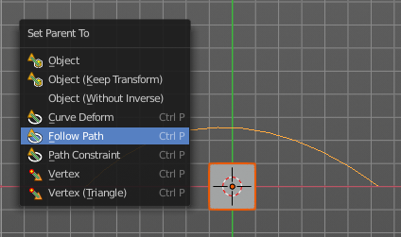
Follow Path
Attaches an object to a curve. The curve then gets used to animate the object position. Every vertice of the curve is one key frame.
Create a curve, create an object, hold down shift and select the curve, make parent ...
Take care of the position and rotation of the object before parenting it to the curve. It influences how the object behaves.
There is a constraint with the same name and functionality. But parenting with follow path will not create such a constraint.

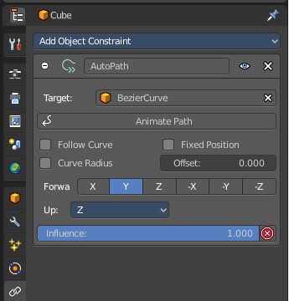
Path Constraint
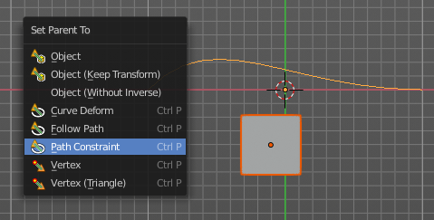
Path constraint adds a AutoPath constraint at the mesh object, which is most probably a wrong labeled path constraint. It is not documented by the Blender developers.

Create a curve, create an object, hold down shift and select the curve, make parent ...
Take care of the position and rotation of the object before parenting it to the curve. It influences how the object behaves.

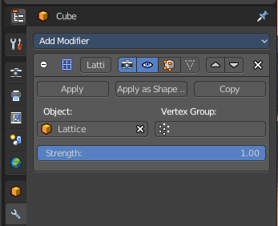
Lattice Deform
Parents a lattice object to the object.
You need a lattice object and a mesh object. Lattice deformations just works with mesh objects.
Create a lattice, create an object, hold down shift and select the lattice, make parent ...
Parent the mesh object to the lattice object with method Lattice Deform. A Lattice Deform constraint will be added at the mesh object.

Take care of the position and size of the lattice object. It influences how the deformation works.

Enter Edit Mode with the lattice object. Deform it. The mesh object will follow the deformation.
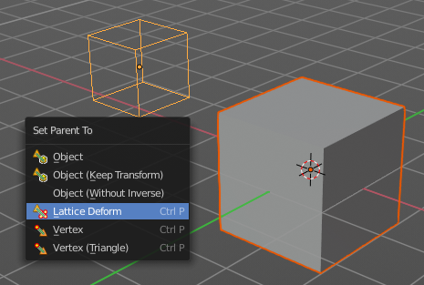
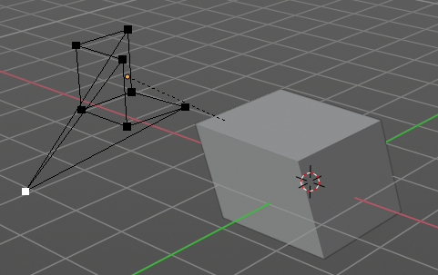

Vertex
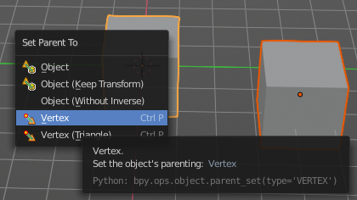
Vertex parents the current object to a vertex of the target object. The vertex will be chosen automatically, it's the
closest vertice of the parent object. When you want to assign the object to a specific vertice, then you have to do
The vertex parenting in Edit mode. You need to have an object type that has vertices. Mesh or curve.
Create a mesh or curve object, create an object, hold down shift and select the mesh object, make parent ...

Vertex (Triangle)
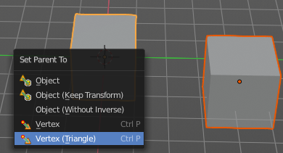
Vertex (Triangle) parents the current object to a face of the target object. The face will be chosen automatically.
It's the closest face of the parent object. When you want to assign the object to a specific face, then you have to
Do the vertex parenting in Edit mode. You need to have an object type that has vertices. Mesh or curve.
Create a mesh or curve object, create an object, hold down shift and select the mesh object, make parent ...

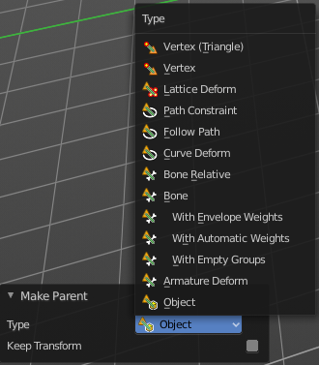
Last Operator Make Parent

Type
Choose the make parent method again. This last operator counts for most of the parent actions.

Keep Transform
Apply transform before parenting.

Object (without inverse)
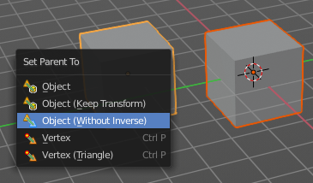
With normal parenting the child object keeps its world transformation.
Without inverse parenting the child object uses the coordinate system of the parent object. As one of the effects you will see that the child objects will jump to the origin of the parent object when parenting.

Clear Parent
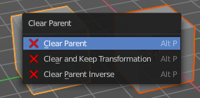
Clear Parent clears the parent relation completely, including involved modifiers.

Clear and Keep Transformation
Clear Parent clears the parent relation completely, including involved modifiers.
But keeps the current visual transformation.

Clear Parent Inverse
Clear Parent Inverse resets the transform corrections applied to the parenting relationship. It does not remove
the parenting itself.

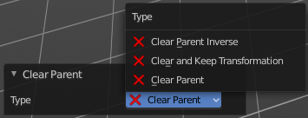
Last Operator Clear Parent
Change the type of clearing.

Relations

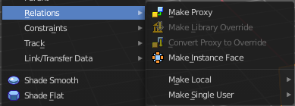
This sub menu contains relations related functionality.

Make Proxy
Makes the active linked object into a local proxy, appending “_proxy” to its name.

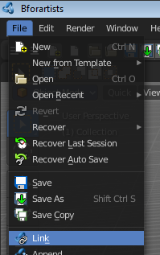
How to:

Create a library file. A file with a cube for example. I called it mylibrarycube for this example. Create a new scene. And link the mylibrarycube object from the library.
The linked cube will reside now in the middle of the viewport. You cannot move it, you cannot edit it.
Now go to Relations, Make Proxy, and make it a proxy object.
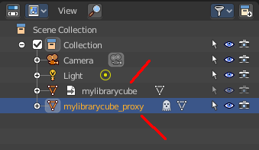
In the viewport the linked cube is not longer visible now. Just the created proxy object. And this proxy object is now editable, and you can move it around.
In the outliner the linked cube greys out, and a new instance called mylibrarycube_proxy is created. This is the editable instance. And the ghost icon tells you that it is a proxy object.
Possible changes are restricted. You can mainly edit and animate transformations of the proxy object and its constraints. Any changes remains local in the current scene, and does not affect the library object.

Make Library Override
Add a local library override to this collection.
This tool works different from Add Override in the outliner. It iterates through the hierarchy of objects and collections based on the selection. And tries to override everything linked.
To work properly, it is important that all the collections needed by the character are children of the root object Both, linked and instantiated. Otherwise the automated overriding may fail.
Library Overrides is the new system designed to replace and supersede Proxies. Most types of linked data-blocks can be overridden, and the properties of those overrides can then be edited. When the library data change, unmodified properties of the override one will be updated accordingly.

Convert Proxy to Override
Converts a proxy to a local library override.

Make Instance Face
Make Instance Face, formerly Make Dupli Face, is a relict from the past, when there was no instancing or parenting feature available in Blender. When you turn an object into a Dupli Face object, then this object becomes an instancing container for this object. All objects in this container just exists once in ram when you duplicate it. No matter how often you duplicate it. This allows to plant whole forests without to run into a memory problem. Since the tree object just loads once into ram. And gets just drawn at different screen positions then.

Usage:
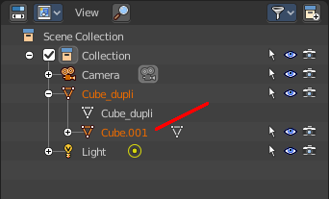
Create an object. Make Instance Face. The name will be extended by a _dupli term.

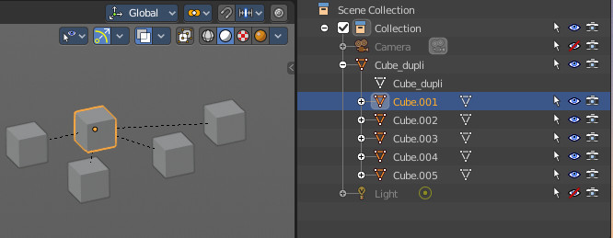
Now in the outliner go into the hierarchy of the dupli object. And duplicate the Cube.001 object inside of it. This is the parent object that you can duplicate. You will see that the duplicated copies will now be connected by a dotted line with the parent object.

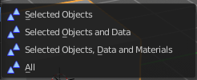
Make Local
You need to have a linked object for that. Make library linked data blocks local to this file. The link to the library object will be lost. And the object acts like you would have created it in the current scene.
There are four different methods available. With which you can also make the dependencies of the library object local. Materials for example.

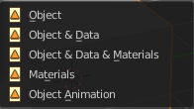
Make Single User
Make linked data local to each object. Additionally, it can also make single-user copies of its dependencies, like meshes, curves, materials, animations…

Constraints

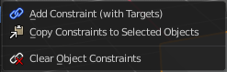
The constraints menu contains some functionality that could also be done in the constraints tab in the Properties editor. Those buttons provides a quicker access though.

Constraints provides you with various limitation methods connected to a target object. For example, you can limit the X position of an object to the X position of the target object. And when you move the target object, then the object will change its X position too.

Add Constraints ( With Targets)
Add Constraints ( With Targets) calls a menu choose the constraints type. It's the same content than in the Constraints tab in the Properties editor.
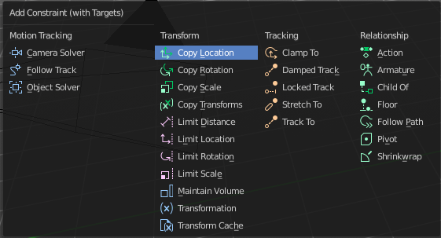
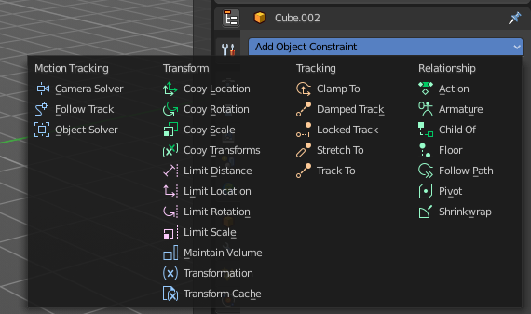

We will not explain every single constraint type here. Please have a look at the constraint types in the manual part for the Properties editor.
Usage:
Select the target object. Hold down Shift key. Now select the object where you want to add the constraints to. Both should be selected. Then choose the constraints type in the menu that you want to add.
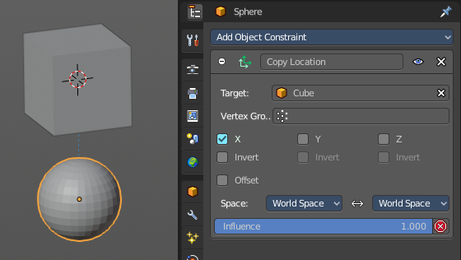
As a result a constraints panel gets created in the Constraints tab in the Properties editor. Tweak the settings further if required. In our example we wanted to limit the X axis. So we added a Copy Location constraint, and unticked Y and Z axis. And when we move the cube around then the sphere will follow in X axis. But not in Y and Z.
In the 3D view a dotted line indicates the relationship.

Last Operator Add Constraints (with Target)

Type
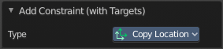
Type is a drop-down box choose the constraints type again.

Copy Constraints to Selected Objects
Copy Constraints to Selected Objects copies a constraint from one object to another.
Useage:
Select the object where you want to copy the constraint to. Hold down Shift and select the object with the constraint. Both should be selected. Then click at Copy Constraints to Selected Objects. This copies the constraint to the object.

Clear Object Constraints
Removes all constraints from the object.

Track

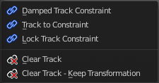
Track constraints are constraints. And adding them could also be done in the constraints tab in the Properties editor. Those buttons provides a quicker access though.

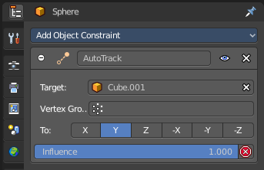
Damped Track Constraint
The Damped Track constraint constrains one local axis of the owner to always point towards Target. It is a Look At constraint.
Usage: select the source object, hold down shift, select the target object, add Damped Track Constraint.
The wrong constraint name called AutoTrack is a Blender bug.

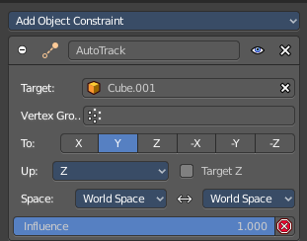
Track to Constraint
This constraint is similar to Damped Track constraints, but provides some more control.
Usage: select the source object, hold down shift, select the target object, add Damped Track Constraint. Constraint will be added at source object.
The wrong constraint name called AutoTrack is a Blender bug.

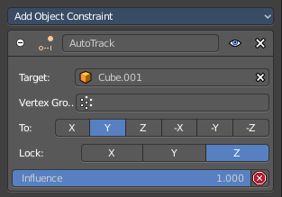
Lock Track Constraint
The Locked Track constraint is basically a Track To constraint. But with a locked axis. Means an axis that cannot rotate. So the constraint can just follow in one defined axis.
The wrong constraint name called AutoTrack is a Blender bug.
Usage: select the source object, hold down shift, select the target object, add Track Constraint. Constraint will be added at source object.

Clear Track
You need to have a Track constraint applied. It removes the track constraint.

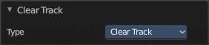
Last Operator Clear track

Type
Type is a drop-down box choose between Clear Track and Clear Track Keep Transformation.

Clear Track - Keep Transformation
This menu item is just relevant when you have a Track constraint applied. Removes the track constraint. But keeps the current position.

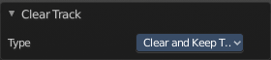
Last Operator Clear track

Type
Type is a drop-down box choose between Clear Track and Clear Track Keep Transformation.

Link / Transfer Data

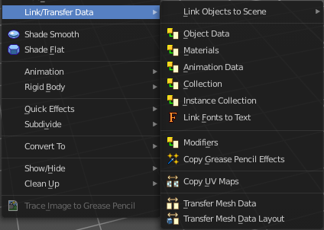
Links objects between scenes or data of the active object to all selected objects. In some case (i.e. Object Data, Modifier) the target objects must be of the same type than the active one or capable of receiving the data. If targets already have some data linked to them, it will be unlinked first.

Link Object to Scene
In Bforartists you can have more than one scene in the blend file. See Scenes tab. The make links menu allows you to link or copy objects between those scenes.

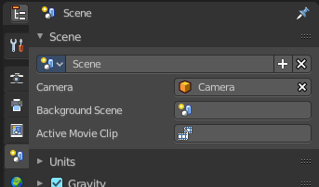
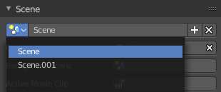

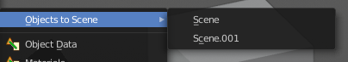
Object to Scene makes the selected object available in the chosen scene. This makes the object exist in two different scenes at once, including position and animation data.
When you want the object not to be shared across two scenes anymore, then you have to make it single user again, which can be done in the relations menu.

Object Data, Materials .. etc
Link this specific data blocks between selected objects.
Select the source object, hold down shift, select the target objects. Perform the action.

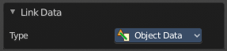
Last Operator Link Data

Type
Choose the data type again that you want to transfer.

Copy UV Maps
Copies the UV map from one object to another. If the selected object doesn’t have any UV maps, then it is created. The Objects must be of type mesh and must have a matching topology.
Select the source object, hold down shift, select the target object. Perform Transfer UV Map.

Transfer Mesh Data
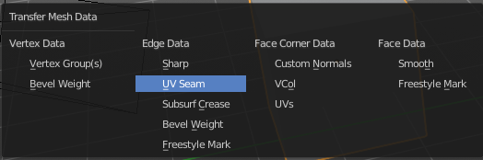
Transfers mesh data from active to selected object.
Select the object that you want to copy the data to, hold down shift, select the source object with the modifications at it. Choose Transfer Mesh Data. A popup with the available methods will appear. Choose what you want to do.
The caveat here is that the operator works in object mode. When you switch modes then the operator quits. And so you can't check if the UV seam transfer for example arrives as it should. This means that you sometimes end in trial and error with the last operator setting until you have your desired result.

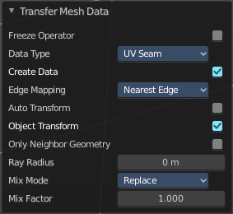
Last Operator Transfer Mesh Data

Freeze Operator
Prevent changes to settings to re-run the operator. This is useful if you are editing several settings at once with heavy geometry.

Data Type
The popup from above. Choose again what you want to do.

Create Data
Add data layers on destination meshes if needed.

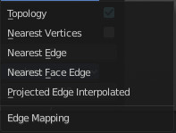
Edge Mapping
Edge mapping determines how edge data gets transferred.

Topology
This method expects to have the same number of items at both objects. Identical objects that got deformed differently for example.

Nearest Vertice
Uses the nearest vertice of the source object for calculation.

Nearest Edge
Uses the nearest edge of the source object for calculation.

Nearest Face Edge
Uses the nearest edge of sources nearest face of the source object for calculation.

Projected Edge Interpolation
A sampling process that casts several rays from along the destination's edge for calculation.

Auto Transform
Automatically computes the transformation to get the best possible match between source and destination meshes.


Only Neighbor Geometry
Source elements must be closer than given distance from destination one. Turning this on reveals further settings.

Max Distance
Maximum allowed distance between source and destination element (for non-topology mappings).

Ray Radius
The width of rays.

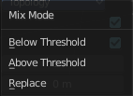
Mix Mode
How to affect destination elements with source values.

Below Threshold
Only replaces destination value if it is below given threshold Mix Factor. How that threshold is interpreted depends on data type, note that for Boolean values this option fakes a logical OR.

Above Threshold
Only replaces destination value if it is above given threshold Mix Factor. How that threshold is interpreted depends on data type, note that for Boolean values this option fakes a logical AND.

Replace
Replaces everything in destination (note that Mix Factor is still used).

Mix Factor
How much of the transferred data gets mixed into existing one (not supported by all data types).

Transfer Mesh Data Layout
Transfers the layout of data layer(s) from active to selected meshes.
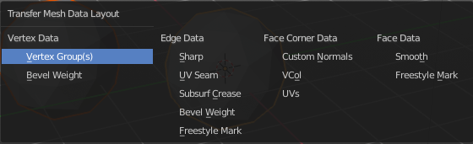
Select the object that you want to copy the data to, hold down shift, select the source object with the modifications at it. Choose Transfer Mesh Data Layout. A popup with the available methods will appear. Choose what you want to do.
The menu has basically the same menu items like Transfer Mesh Data. The difference is in what you can do in the last operator. It transfers the whole data layer.

Last Operator Transfer Mesh Data Layout

Data Type
Choose again what you want to do.

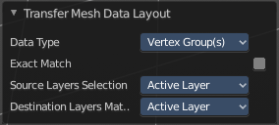
Exact Match
Also Delete some data layers from destination if necessary, so that it matches the source exactly.

Source Layers Selection
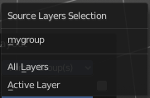
Which layers to transfer, in case of multi-layer types.

Mygroup
Mygroup is in this case a vertex group i have created for demonstration purposes.

Active Layer
Only transfer the active data layer.

All Layers
Transfer all data layers.

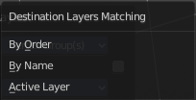
Destination Layers Matching
How to match source and destination layers.

By Name
Match target data layers to affect by name.

By Order
Match target data layers to affect by order (indices).

Active Layer
Only transfer the active data layer.

Shade Smooth and Shade Flat
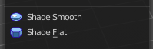
Sets the shading for the object to either smooth or flat. Flat means that every face of the object shows facettet, with a sharp edge. Smooth means that the edges are not longer to see.
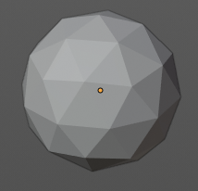
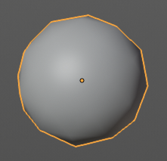

Animation
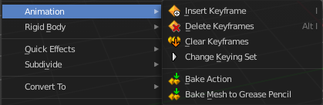

Insert Key frame
Inserts a key frame.
When your object does have a active keying set, then a click at the button inserts the key frame directly. When a keying set is missing then you will see a Insert Key frame menu choose the keying method.

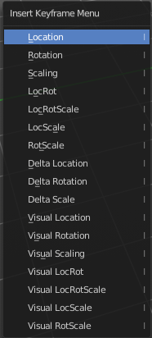
Insert Key frame Menu
The keying set defines what kind of key frames gets recorded. When you start with an
animation, and your object does not have a keying set yet, then you will be prompted with a menu choose the proper keying set. The Insert Key frame menu.
Note that this just adds a keying set to the current key frame. And not to the whole object. That's why the keying set menu down right stays empty when you add a key frame this way.

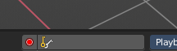

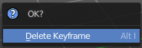
Delete Key frame
Removes the current active key frame for the selected object. You will get a confirmation dialogue.

Clear Key frames
Clears all animation, and removes all key frames for the selected object.

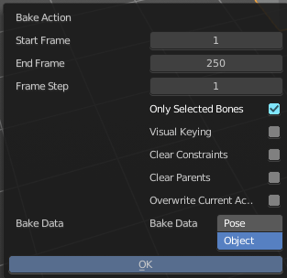
Bake Action
Bake Action bakes the object animation to a new action. Bake action calls a panel adjust the settings for the new action.
The panel has the same settings than the last operator panel.

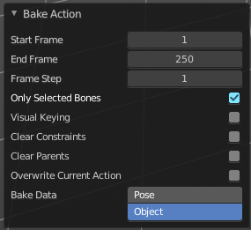
Last Operator Bake Action

Start Frame
Defines the start frame for baking.

End Frame
Defines the end frame for baking.

Frame Step
Defines the frame step for baking.

Only Selected Bones
Pose Baking only.

Visual Keying
Key frame from the final transform.

Clear Constraints
Remove all constraints from keyed objects / bones, and do visual keying.

Clear Parents
Bake animation onto the object, then clear parents (objects only)

Overwrite current Action
Bake Action into current action instead of creating a new one.

Bake Data
Which data transformations to bake to. You have the choice between Pose and Object here.

Bake Mesh to Grease Pencil
Bakes mesh animation to grease pencil strokes.

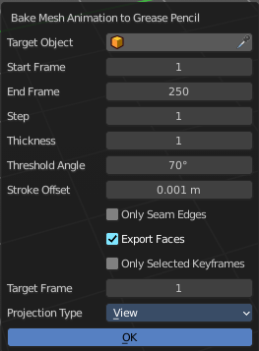
Bake Mesh Animation to Grease Pencil
When you use the Bake Mesh to Grease Pencil tool then a menu pops up with further settings.

Target Object
Target grease pencil object. Leave emtpy to create a new stroke.

Start Frame
The start frame of the animation.

End Frame
The end frame of the animation.

Step
Step between generated frames.

Thickness
The thickness of the grease pencil stroke.

Threshold Angle
Threshold to determine the end of the strokes.

Stroke Offset
Stroke offset from fill.

Only Seam Edges
Convert only seam edges.

Export Faces
Export faces as filled strokes.

Only Selected Keyframes
Convert only selected keyframes.

Target Frame
The destination frame.

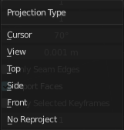
Projection Type
How to project the grease pencil stroke.

OK
Accept the settings.

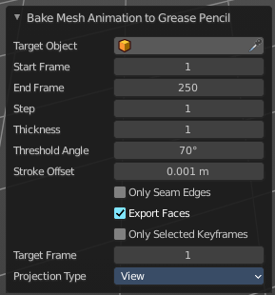
Last Operator Bake Mesh Animation to Grease Pencil
In the last operator you can again adjust the settings. It is the same settings than in the settings dialog. So we won't cover it again.

Rigid Body
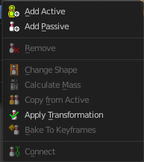
Rigid Bodies belongs to physics. And can be added and modified in the physics tab in the Properties editor. This menu items here is just a quick way to add and modify the most basic things from within the 3D view.
The greyed out menu items becomes active when a rigid body is at the object.

Add Active
Add Active adds a rigid body to the selected object. The type of this rigid body is active. This is useful for any
actively moving object. Characters, bullets, etc.

Add Passive
Add Active adds a rigid body to the selected object. The type of this rigid body is passive. This is useful for any
static object, like ground for example.

Last Operator Add Rigid bodies
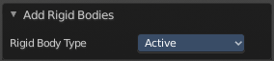
The rigid body type is a drop-down box choose if the type of the rigid body is active or passive.

Remove
Remove simply removes the rigid body from the current object.

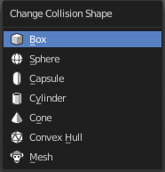
Change shape
Change Shape opens a pop-up menu change the shape of your rigid body.

Last Operator Change Collision shape
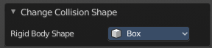
Rigid Body Shape is a pop-up menu change the shape of your rigid body again.

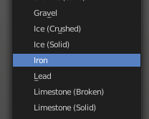
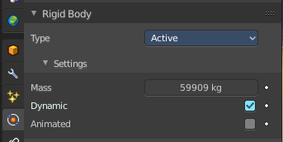
Calculate Mass
Calculate Mass does NOT calculate the mass. But gives you a long pop-up menu list choose between different predefined mass set-ups. The corresponding value will then be set in the physics settings in the Rigid Body settings.

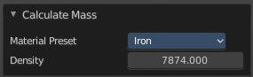
Last Operator Calculate Mass

Material Preset
Material Preset is a pop-up menu choose the type of preset again.

Density
Set a custom density for the material preset.

Quick Effects
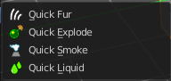
The quick effects menu contains some predefined basic Particle effects. They can be tweaked further in the Properties editor then.
You need to have a mesh object selected.

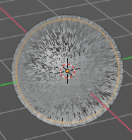
Quick Fur
Adds a particle system with Fur settings.

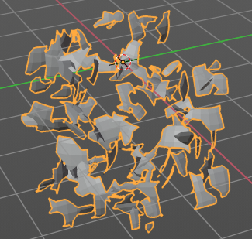
Quick Explode
Adds a particle system that lets the selected object explode into pieces.
Hit play to play the animation.

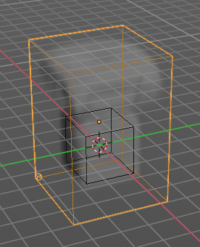
Quick Smoke
Adds a particle system with a simple smoke.

Hit play to play the animation.

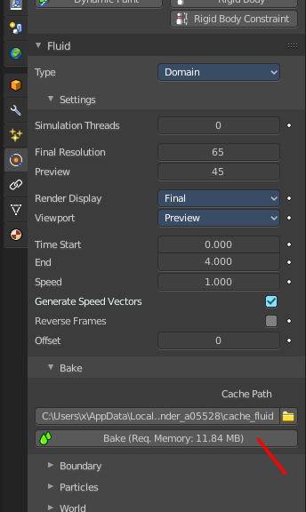
Quick Fluid
Adds a particle system with Fluid settings.
This feature does not completely work out of the box. You need to bake the animation first. This can be done in the Properties Editor, Particles Tab, Fluid Panel in the Bake sub panel.

Subdivide

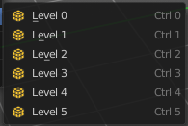
Subdivide is a menu where you can quickly set the subdivision level of the selection. What it does is to add a SDS modifier in the Properties Editor if required. And set the SDS level to the needed value. Crtrl 0 sets SDS to level 0. Ctrl 1 sets SDS level to 1 , and so on.

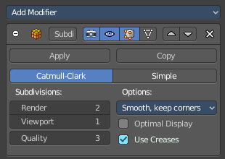
SDS happens at Object mode level. Even when you apply it in the Edit Mode! And it happens at the whole object.

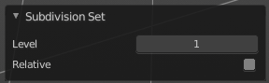
Last Operator Subdivision Set

Level
Adjust the SDS level.

Relative
Applies the Subsurf Level as an offset relative to the current level.

Convert to

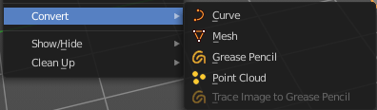
Convert to is a menu to convert curves object types to mesh objects or grease pencil strokes, and mesh object types to curves.
The Gpencil tools just appears with a grease pencil object selected.

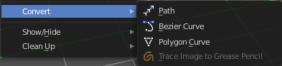
Curve
Converts a selected Mesh or Text Object to a Curve Object.

Mesh
Converts a selected object to a Mesh Object.

Grease Pencil
Converts a selected curve to a grease pencil stroke.

Point Cloud
Converts a selected object to a point cloud object.

Last Operator Convert to

Target
Target is a drop-down box that allows you to choose the convert method again.

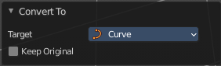
Target Point Cloud, Mesh, Curve

Keep Original
With this option ticked the original object gets kept. And a new object gets created.

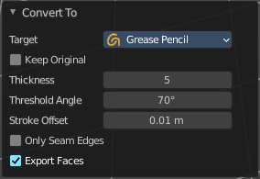
Target Grease Pencil

Keep Original
With this option ticked the original object gets kept. And a new object gets created.

Thickness
The thickness of the grease pencil strokes.

Threshold Angle
The threshold to determine the end of the strokes.

Stroke Offset
Offset strokes from fill.

Only Seam Edges
Convert only seam edges to grease pencil strokes

Export Faces
Export faces as filled strokes.

Gpencil to Path
Converts a grease pencil object to a path.

Gpencil to Bezier Curves
Converts a grease pencil object to a bezier curve.

Gpencil to Mesh
Converts a grease pencil object to a mesh.

Last Operator Convert Grease Pencil

Type
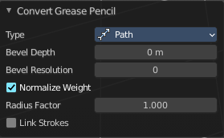
Type is a drop-down box that allows you to choose the convert method again.

Bevel Depth
A curve can have a extruded geometry with bevel. Adjust the bevel depth.

Bevel Resolution
A curve can have a extruded geometry with bevel. Adjust the bevel resolution.

Normalize Weight
Normalize the weight, set from stroke width.

Radius Factor
Multiplier for the points radii, set from stroke width.

Link Stroke
Link strokes with zero radius sections of curves.

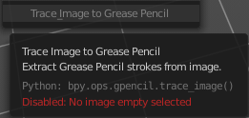
Trace Image to Grease Pencil
Extract grease pencil strokes from an image in an image empty.

Show/Hide
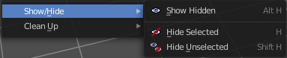
Show/Hide is a menu. Show or hide objects in the viewport.

Show Hidden
Makes all geometry visible again.

Hide Selected
Hides the selected geometry.

Hide Unselected
Hides the not selected geometry. The selected geometry stays visible.

Clean Up

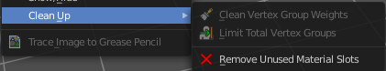
Clear Vertex Group Weights
Remove not required vertex group assignments.

Limit Total Vertex Groups
Limit deform weights associated with a vertex to a specific number by removing lowest weights.

Remove Unused Material Slots
Remove Unused Material Slots.

Object specific menu items

Some object types have some extra menu entries in the object menu. Those operators can usually be found at the end of the menu when you have such an object selected.

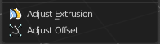
Curve and Text
Text is a special kind of a curve type. So this menu items also shows with text objects.

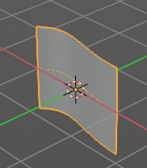
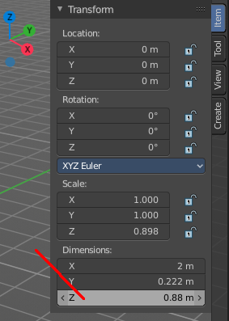
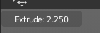
Adjust Extrusion
Extrudes a surface out of a curve or text object.

In the header you can see the height of the extrusion. In the Transform panel in the sidebar you can adjust this height also afterwards. The Z value.

Adjust Offset
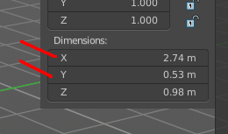
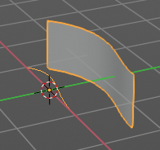

Adjust Offset is just of interest when you have an extruded surface at the curve. It scales the surface size in x and z direction.


Empty, Image and Force Fields
Reference and Background Image is nothing else than an empty of type Image. So this menu entry also shows for the image types. Same counts for Force Fields. They are empties of a special kind.

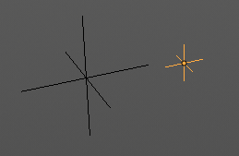
Adjust Empty Display Size
Scale the size of the empty in the viewport.
Note, this value does not show elsewhere. And there is no way to reset it to the default size except to scale it again with Empty Draw Size. The value in the header will help you.

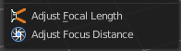
Camera

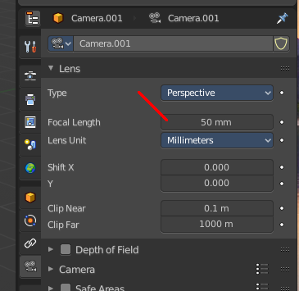
Adjust Focal Length
Changes the focal length of the camera. You can adjust it afterwards in the properties editor.
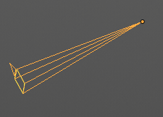

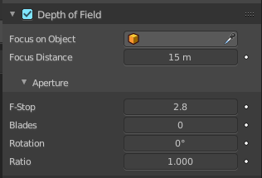
Adjust Focus Distance
Changes the focus distance for depth of field. You can adjust it afterwards in the properties editor. The values in the depth of field are not as exact as the dof distance values though.

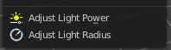
Light
Each light type has its own settings. Power is the same in all. When you adjust the values then you will see a string with the values in the header.

Power
Light energy adjusts the power of the light.

Interactive Light Track
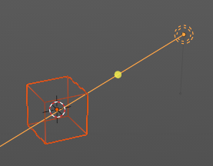
Sun, Spot and Arealight.
Interactively points a light to a target object. Without a target object the light will just rotate around like with the rotation widget. But with a target object the depth of the light ray will cross the target object. It still asks for some aiming. It is no look at tool. You can aim still a bit off of the target object. But in depth the ray is aligned with the object.
Select the object, hold down shift, select the lamp. So that both are selected. Press the hotkey shift t to activate the tool. Aim where you want the light ray to go.
With holding down ctrl too you can move the lamp around and the ray will still try to point towards the object.

Point light

Adjust Light Power
Adjust the power of the light. The light power setting is in the properties editor in the light panel in the object data properties tab.

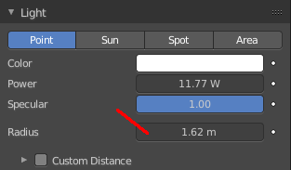
Adjust Light Radius
Adjust the radius of the point light.

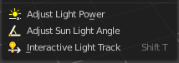
Sun light

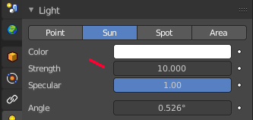
Adjust Light Power
Adjust the power of the light. The light power setting is in the properties editor in the light panel in the object data properties tab.

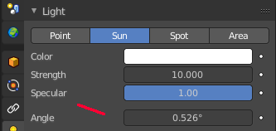
Adjust Sun Light Angle
Adjust the angle of the sun light.

Interactive Light Track
Sun, Spot and Arealight.
Interactively points a light to a target object. Without a target object the light will just rotate around like with the rotation widget. But with a target object the depth of the light ray will cross the target object. It still asks for some aiming. It is no look at tool. You can aim still a bit off of the target object. But in depth the ray is aligned with the object.
Select the object, hold down shift, select the lamp. So that both are selected. Press the hotkey shift t to activate the tool. Aim where you want the light ray to go.
With holding down ctrl too you can move the lamp around and the ray will still try to point towards the object.

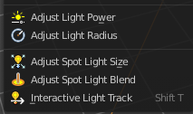
Spot light

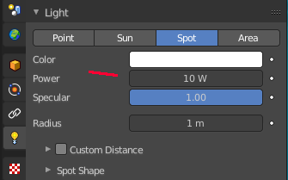
Adjust Light Power
Adjust the power of the light. The light power setting is in the properties editor in the light panel in the object data properties tab.

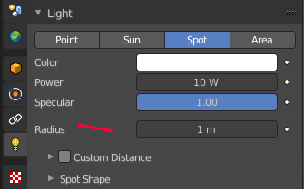
Adjust Light Radius
Adjust the radius of the light.

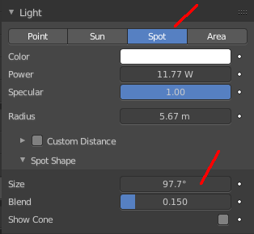
Adjust Spot Light Size
Adjust the angle of the spotlight beam. Note that the value in the header is in radians, while the value in the panel is in degrees.

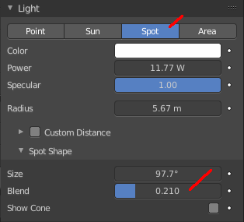
Adjust Spot Light Blend
Adjust softness of the spotlight edge.

Interactive Light Track
Sun, Spot and Arealight.
Interactively points a light to a target object. Without a target object the light will just rotate around like with the rotation widget. But with a target object the depth of the light ray will cross the target object. It still asks for some aiming. It is no look at tool. You can aim still a bit off of the target object. But in depth the ray is aligned with the object.
Select the object, hold down shift, select the lamp. So that both are selected. Press the hotkey shift t to activate the tool. Aim where you want the light ray to go.
With holding down ctrl too you can move the lamp around and the ray will still try to point towards the object.

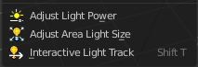
Area light

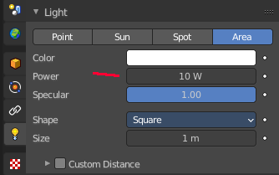
Adjust Light Power
Adjust the power of the light. The light power setting is in the properties editor in the light panel in the object data properties tab.

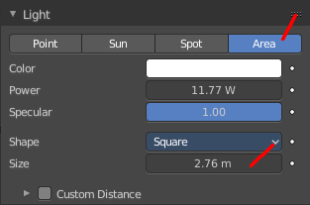
Adjust Area Light Size
Area light only.
Scale the size of the area light. Size Y appears with Shape Rectangle.

Interactive Light Track
Sun, Spot and Arealight.
Interactively points a light to a target object. Without a target object the light will just rotate around like with the rotation widget. But with a target object the depth of the light ray will cross the target object. It still asks for some aiming. It is no look at tool. You can aim still a bit off of the target object. But in depth the ray is aligned with the object.
Select the object, hold down shift, select the lamp. So that both are selected. Press the hotkey shift t to activate the tool. Aim where you want the light ray to go.
With holding down ctrl too you can move the lamp around and the ray will still try to point towards the object.

